**Web 9 CS-248 Web and Internet Programming**

# PHP, HTML and MySQL Assignment

**Due: Tuesday April 18th by class** Submission by e-mailing the link to your html form to [masont@uwstout.edu.](mailto:masont@uwstout.edu)

# Complete the following for full credit on this assignment (100 points)

This project uses a form in an html document to collect user information, the information is submitted to a PHP page that processes the data and inserts it into the user table for movie rental

company.

1. Create an HTML file containing a form to submit the following data to the myflix registration page you will build in part 2. (40 points)
   1. Create input fields for first name, last name, and e-mail address.
   2. Create three radio buttons for the different levels of membership (platinum, gold, and bronze).
   3. Submit and reset buttons.

## Example

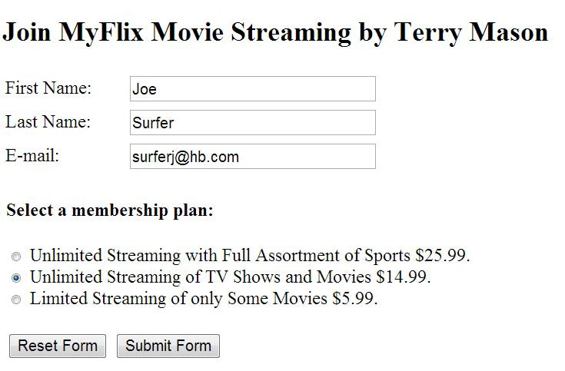

Debug your page by making sure all parameters are transmitted to the server properly. You may set the action for the form tag below to view all parameters passed by the form. You need to redirect the action to your PHP page for the final submission.

<form action="<http://mscs-php.uwstout.edu/web/parameters.php>" method="post" >

1. Create a PHP file in the same directory as the HTML form. These must be in a directory that Dreamweaver will publish to the server. The form should now be directed to (action) this PHP page. The PHP page will do the following:
   1. Validate that the form data has content for the input of first name, last name, e-mail address, and membership level. (You may assume that the email is valid if it has content for this assignment.)
   2. If the data is **NOT** all valid, give a message on the errors and a link back the form.
   3. If the data is valid, complete the following tasks: (40 points)
      1. Insert the user information into the myflix database
         1. Connect using PHP to the database at **mscs-mysql.uwstout.edu**, with user **web16**, and password of **Spring16!** for this assignment. This will be used to make the connection.
         2. Select database **myflixstreaming**.
         3. Create the insert string in PHP using the data passed from the form.
         4. Insert the data including your Stout user id in the final field. See the notes on SQL Updates and Inserts for the user table details. Replace masont in the insert statement to be your own stout username.
         5. View the user table to confirm that it worked correctly at

[http://mscs-php.uwstout.edu/2017WIN/cs/248/002/masont/Web12/users.php](http://mscs-php.uwstout.edu/2017WIN/cs/248/002/masont/Web12/users.php%20) with your user appearing at the end of the table. I will truncate the table (drop all data) periodically when it gets too large.

* + 1. Print out a confirmation page (20 points)
       1. Output first name
       2. Confirm membership level
       3. Thank the user for joining the myflix service.

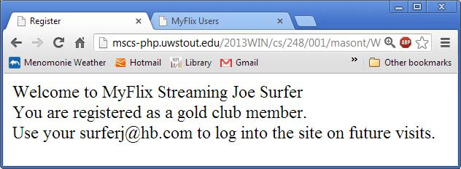

## Submission:

**E-mail me the link to your form (html) program on mscs-php.uwstout.edu** at

[masont@uwstout.edu.](mailto:masont@uwstout.edu) **Your links must start with mscs-php.uwstout.edu/.**